A Systematic Review for Stock Price Prediction Using Machine Learning
Adi Cahyono^{1*}

¹ Faculty of Science and Technology, Master of Informatics, Universitas Islam Negeri Maulana Malik Ibrahim, Malang, Indonesia
Jl. Gajayana No. 50 Dinoyo, Kec. Lowokwaru, Kota Malang, Jawa Timur, 65144, Indonesia
Email: ¹250605210001@student.uin-malang.ac.id
Correspondence Author Email: ¹250605210001@student.uin-malang.ac.id

Abstract−The abstract is a brief summary of the manuscript to help the reader quickly ascertain the main research problem, the method used as a solution to the problem encountered, the research objectives and interim results of the research which can be in the form of numbers/percentages according to the research needs. The abstract should be clear and informative, providing a statement for the problem under study. The length of the abstract is between 170 to 230 words. In social science papers, it is mandatory to have a research location, number of respondents, data testing methods/analysis techniques from your research. The abstract does not have citations/references. Avoid unusual abbreviations and define all symbols used in the abstract. Using keywords related to the research topic is recommended.
Keywords: SLR; Stock Price; Machine Learning; Deep Learning; Prediction
1. INTRODUCTION
Stock price prediction using AI methods has emerged as a significant area of research due to the inherent complexity and volatility of financial markets. The integration of artificial intelligence (AI) and machine learning (ML) techniques offers a promising approach to enhancing the accuracy of stock market forecasts. AI's ability to process large datasets rapidly and discern complex patterns makes it superior to traditional analytical methods, which often struggle with the nonlinearity and dynamics of stock prices. (Al-Alawi & Alshakhoori, 2024; Pillai & Bi, 2024).
Various AI techniques, including neural networks, support vector machines, and deep learning models such as Long Short-Term Memory (LSTM), have been employed to predict stock prices by analyzing historical data, technical indicators, and sentiment from news and social media. (Gangthade, 2024).Hybrid models that combine multiple AI techniques have been shown to outperform traditional methods by effectively handling non-linear complexities and temporal dynamics (Al-Alawi & Alshakhoori, 2024; Sun, 2025).
Despite these advancements, challenges remain, such as integrating qualitative factors like a company's strategic decisions and the impact of unforeseen events like pandemics or geopolitical tensions, which are difficult to quantify and incorporate into predictive models. (Whig et al., 2024). Moreover, the quality of data and model interpretability remain ongoing concerns that researchers aim to address by developing more sophisticated models and incorporating cutting-edge technologies such as reinforcement learning. (Sun, 2025).
The continuous evolution of AI in stock market prediction not only aids investors in making informed decisions but also contributes to the broader financial industry by enhancing investment strategies and risk management practices. (Al-Alawi & Alshakhoori, 2024; Arora et al., 2024). As AI technologies advance, their role in stock market prediction is expected to grow, offering more refined and reliable forecasting tools for investors and financial analysts alike. (Gong, 2022).
2. RESEARCH METHODS
The method used in this literature review study is the systematic literature review. This review was conducted in accordance with the PRISMA 2020 Statement. (Page, McKenzie, et al., 2021), which comprises a checklist and a flow diagram. The PRISMA Elaboration and Explanation (Page, Moher, et al., 2021) Enhances the understanding, usage, and
dissemination of the PRISMA 2020 Statement by providing examples and explanations for each checklist item.
To carry out the meta-review, we adhered to the PRISMA 2020 guidelines. (Page, McKenzie, et al., 2021) And searched for pertinent systematic reviews on the prediction of stock markets using AI technologies, including ML and DL methods. The first step in this methodical strategy was to look for helpful scholarly articles in three well-known databases: SCOPUS. We employed inclusion and exclusion criteria to screen the retrieved records and selected ten papers for the final dataset. Subsequently, we extracted and coded the data from the included reviews and analyzed them from four essential perspectives: predictor methodologies, information sources, predictive model performance metrics, limitations, and future recommendations. In addition to following a well-defined research methodology, specific criteria must be met for selecting primary publications for this work.
2.1 Literature Selection Criteria
Our research phase involved retrieving relevant publications for the systematic review and selecting papers based on predetermined criteria. The strategic selection of databases further emphasized the importance of this phase, careful selection of search terms, effective use of filtering tools, and a rigorous review process. Databases were strategically selected to capture the broad scope of literature relevant to our research topic. Therefore, the Scopus database was used for paper extraction, given its reputation as a respected academic reference and its coverage of a diverse range of high-quality scholarly articles (Wang et al., 2016).
Keywords used included: "Stock Price," "Prediction," "Stock Market," and "Stock". The articles reviewed were limited to the period 2020-2025 to ensure they remain current and relevant. Therefore, the initial stage should include several questions to be answered after the systematic review, as well as the inclusion, exclusion, and quality criteria. The research questions expected to be answered by this systematic review are presented in Table 1. The inclusion and exclusion criteria are presented in Table 2.
Table 1. Research Questions
ID | Research Questions (RQ)
RQ1 | Which AI methods and technologies are most commonly used to predict stock market prices?
RQ2 | Which information sources are most often used to predict stock market prices?
RQ3 | Which metrics are most commonly used to verify the performance of a predictive model?
Table 2. Inclusion and Exclusion Criteria
Criterion | Inclusion | Exclusion
Year of publication | 2020-2025 | In addition to 2019-2025
Language | English | Non-English
Subject area | Computer Science | Non-Computer Science
Document type | Article and Conference | Non-Articles and Conference
Country/region | Indonesia | Non-Indonesia
Source type | Journal | Non-Journal
Open access | Yes | No

2.2 Research Stages (Subtitle Times New Roman 10, Left, After 6 pt)
At this stage, the researcher began searching for articles related to stock prices. Related articles will be filtered according to Table 2. Based on the results of the article search, the initial identification stage yielded 3279 articles. Furthermore, after the identification stage was completed, 25 articles were selected, of which seven did not match the AI topic. From this process, 18 articles were produced, which were then filtered again because they did not use the AI method; 5 were excluded. The final result of this stage was 13 articles that met the requirements for this systematic literature review. The stages of the article search used in the systematic literature review are shown in Figure 1.
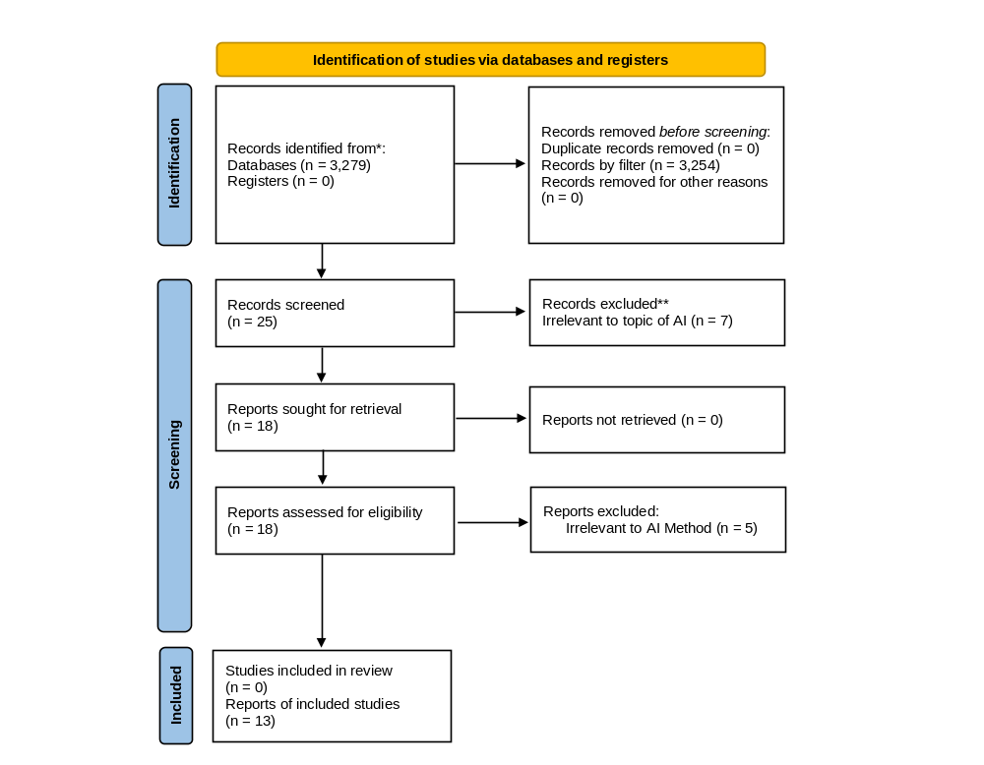
Figure 1. The number of articles separated during PRISMA

3. RESULTS AND DISCUSSION
The articles selected and reviewed by the author were then categorized according to predefined keywords. To facilitate this process, the author created a characteristics table based on the research findings. The characteristics table is shown in Table 3.
Table 3. Review the characteristics of the analyzed articles
Reference | Aim of Review | Date range of included studies
(Hansun & Young, 2021) | This study aims to apply Long Short-Term Memory (LSTM) networks for stock price prediction, focusing on stocks included in the LQ45 index. The review also discusses various forecasting methods for modeling stock price movements. | 2021
(Tarno et al., 2021) | This review assesses risk measurement using Value-at-Risk (VaR), focusing on modeling stock return volatility with ARCH/GARCH models. It also evaluates the ARIMA–GARCH approach for effective risk prediction. | 2012-2019
(Hoyyi et al., 2021) | This review evaluates the Variance Gamma (VG) model in finance by addressing the limitations of the Black–Scholes–Merton model and applying VG to stock price prediction. | 2019-2020
(Budiharto, 2021) | This review analyzes big data using R and LSTM for stock forecasting, with a particular focus on short-term data selection to improve prediction accuracy. It also highlights the importance of time series analysis in financial forecasting. | No mention.
(Ahmar et al., 2021) | This review aims to identify suitable models for predicting stock prices in BRIC countries by comparing the effectiveness of the ARIMA, SutteARIMA, and Holt–Winters methods. The objective is to assess their forecasting performance better to anticipate the economic impacts of stock price trends. | 2019-2020
(Mayatopani, 2021) | This review assesses the predictive capability of neural networks for financial time series by comparing their forecasting accuracy with that of GARCH models. It also explores optimal neural network architectures across different data samples to enhance prediction performance. | No mention.
(A. D. Hartanto et al., 2023) | This review aims to forecast stock price fluctuations using the LightGBM algorithm to achieve high accuracy, while comparing its performance with that of other forecasting models. | 1992-2022
(Zein et al., 2024) | This study aims to evaluate the N-BEATS model for stock price prediction accuracy, compare its performance with LSTM architectures, and support informed investment decisions in the Indonesian stock market. | 2013-2023
(Kristiyanti et al., 2024) | This review examines the impact of inflation on investors’ purchasing power by focusing on stock price forecasting in Indonesia’s transportation sector. The study applies data mining techniques within the CRISP-DM framework to enable systematic, structured analysis. | 2011-2023
(S. Hartanto & Gunawan, 2024) | This review aims to enhance stock market prediction using deep learning models by investigating the integration of technical indicators into the Temporal Fusion Transformer (TFT). The study explores forecasting strategies to generate more accurate insights for informed investment decision-making. | 2019-2024
(Munthe et al., 2024) | This review aims to improve the accuracy of stock market trend prediction by applying advanced techniques and addressing class imbalance in financial datasets using SMOTE. It emphasizes integrating machine learning and deep learning models within a stacked framework to enhance predictive performance. | No mention.
(Sadewa et al., 2025) | This study aims to develop a stock price prediction system for Netflix by evaluating the accuracy of the Simple Exponential Smoothing and Weighted Moving Average methods. The research is motivated by the increasing public interest in stock investment, highlighting the need for reliable forecasting models to support data-driven investment decision-making. | 2019-2024
(Gunaryati et al., 2025) | This review aims to improve the accuracy of Sharia-compliant stock price forecasting by proposing a hybrid ARIMA–LSTM model integrated with LOWESS regression. The study addresses the challenges of high volatility and non-linear patterns inherent in stock price data. | No mention.

This section describes the results of the study. Results should be presented clearly and concisely. Authors should explore the novelty or contribution of the research to the literature used. Present clearly the results of testing, analysis, and discussion using primary, relevant, and up-to-date references.
Figures and tables must be placed as close as possible to their reference points in the text and must be numbered sequentially as they appear in the text. All Figures and Tables must have a title (minimum 2 words) and must be referred to from within the description of the tables and figures. In this case it must be added and numbered sequentially in decimal numbers with descriptive information. Avoid colorful images.
This section contains the results and discussion of the results of the research, which can be made in advance of the research methodology. This section also represents explanations in the form of explanations, pictures, tables and others. The number of words in this section is around 1800 words min.
3.1 Discussion
Must have a discussion section that explains the discussion of the research results in relation to the hypotheses taken in the research. The discussion sub-section also compares with studies from similar research results used in the introductory section. References are also mandatory in this section.
4. KESIMPULAN
The conclusion section contains the final results of the research, the limitations of the research and possible improvements in further research. The conclusion also contains answers to all the problems contained in the research. The contents of the conclusion may not be in the form of points, but in the form of paragraphs (1 paragraph). The number of words in this section is around 200 words min.
REFERENCES (After 6 pt, Before 6 pt)
Ahmar, A. S., Singh, P. K., van Thanh, N., Tinh, N. V., & Hieu, V. M. (2021). Prediction of BRIC stock price using ARIMA, SutteARIMA, and holt-winters. Computers, Materials and Continua, 70(1), 523–534. https://doi.org/10.32604/cmc.2022.017068
Al-Alawi, A. I., & Alshakhoori, N. (2024). Stock Price Prediction Using Artificial Intelligence: A Literature Review. 2024 ASU International Conference in Emerging Technologies for Sustainability and Intelligent Systems, ICETSIS 2024, 542–547. https://doi.org/10.1109/ICETSIS61505.2024.10459442
Arora, S., Pandey, A., & Batta, K. (2024). Prediction of Stock Market Using Artificial Intelligence Application. In Deep Learning Tools for Predicting Stock Market Movements (pp. 185–202). https://doi.org/10.1002/9781394214334.ch8
Budiharto, W. (2021). Data science approach to stock prices forecasting in Indonesia during Covid-19 using Long Short-Term Memory (LSTM). Journal of Big Data, 8(1). https://doi.org/10.1186/s40537-021-00430-0
Gangthade, R. A. (2024). Stock Price Prediction Using Machine Learning. International Journal for Research in Applied Science and Engineering Technology, 12(4), 3472–3477. https://doi.org/10.22214/ijraset.2024.60725
Gong, Y. (2022). The progress and state-of-art applications of machine learning for stock price prediction. BCP Business & Management, 23, 537–542. https://doi.org/10.54691/bcpbm.v23i.1396
Gunaryati, A., Mutiara, A. B., & Puspitodjati, S. (2025). Enhancing Sharia Stock Price Forecasting using a Hybrid ARIMA-LSTM with Locally Weighted Scatterplot Smoothing Regression Approach. Journal of Applied Data Sciences, 6(1), 683–694. https://doi.org/10.47738/jads.v6i1.514
Hansun, S., & Young, J. C. (2021). Predicting LQ45 financial sector indices using RNN-LSTM. Journal of Big Data, 8(1). https://doi.org/10.1186/s40537-021-00495-x
Hartanto, A. D., Kholik, Y. N., & Pristyanto, Y. (2023). Stock Price Time Series Data Forecasting Using the Light Gradient Boosting Machine (LightGBM) Model. International Journal on Informatics Visualization, 7(4), 2270–2279. https://doi.org/10.30630/joiv.7.4.1740
Hartanto, S., & Gunawan, A. A. S. (2024). Temporal Fusion Transformers for Enhanced Multivariate Time Series Forecasting of Indonesian Stock Prices. In International Journal of Advanced Computer Science and Applications (Vol. 15, Issue 7). https://doi.org/10.14569/IJACSA.2024.0150713
Hoyyi, A., Rosadi, D., & Abdurakhman. (2021). Daily stock prices prediction using variance gamma model. Journal of Mathematical and Computational Science, 11(2), 1888–1903. https://doi.org/10.28919/jmcs/5469
Kristiyanti, D. A., Pramudya, W. B. N., & Sanjaya, S. A. (2024). How can we predict transportation stock prices using artificial intelligence? Findings from experiments with Long Short-Term Memory based algorithms. International Journal of Information Management Data Insights, 4(2). https://doi.org/10.1016/j.jjimei.2024.100293
Mayatopani, H. (2021). Implementation of ANN and GARCH for Stock Price Forecasting. Journal of Applied Data Sciences, 2(4), 109–134.
Munthe, I. R., Rambe, B. H., Hanum, F., Amanda, A. T., Hutagaol, A. S. R., & Harianto, R. (2024). Implementation of Stacking Technique Combining Machine Learning and Deep Learning Algorithms Using SMOTE to Improve Stock Market Prediction Accuracy. Journal of Applied Data Sciences, 5(4), 2079–2091. https://doi.org/10.47738/jads.v5i4.421
Page, M. J., McKenzie, J. E., Bossuyt, P. M., Boutron, I., Hoffmann, T. C., Mulrow, C. D., Shamseer, L., Tetzlaff, J. M., Akl, E. A., Brennan, S. E., Chou, R., Glanville, J., Grimshaw, J. M., Hróbjartsson, A., Lalu, M. M., Li, T., Loder, E. W., Mayo-Wilson, E., McDonald, S., … Moher, D. (2021). The PRISMA 2020 statement: An updated guideline for reporting systematic reviews. Bmj, 372, n71. https://doi.org/10.1136/bmj.n71
Page, M. J., Moher, D., Bossuyt, P. M., Boutron, I., Hoffmann, T. C., Mulrow, C. D., Shamseer, L., Tetzlaff, J. M., Akl, E. A., Brennan, S. E., Chou, R., Glanville, J., Grimshaw, J. M., Hróbjartsson, A., Lalu, M. M., Li, T., Loder, E. W., Mayo-Wilson, E., Mcdonald, S., … Mckenzie, J. E. (2021). PRISMA 2020 explanation and elaboration: Updated guidance and exemplars for reporting systematic reviews. The BMJ, 372, n160. https://doi.org/10.1136/bmj.n160
Pillai, R. H., & Bi, A. (2024). Revolutionizing Stock Market Predictions: Exploring the Role of Artificial Intelligence. In Deep Learning Tools for Predicting Stock Market Movements (pp. 227–248). https://doi.org/10.1002/9781394214334.ch10
Sadewa, B., Safwandi, & Fajriana. (2025). Implementation of Simple Exponential Smoothing and Weighted Moving Average in Predicting Netflix Stock Prices. International Journal of Engineering, Science and Information Technology, 5(1), 264–271. https://doi.org/10.52088/ijesty.v5i1.708
Sun, J. (2025). Stock price prediction model based on machine learning. Transactions on Computer Science and Intelligent Systems Research, 9, 294–298. https://doi.org/10.62051/0e4z6k33
Tarno, Maruddani, D. A. I., Rahmawati, R., Hoyyi, A., Trimono, & Munawar. (2021). Arma-garch model for value-at-risk (Var) prediction on stocks of pt. astra agro lestari.tbk. Journal of Mathematical and Computational Science, 11(2), 2136–2152. https://doi.org/10.28919/jmcs/5453
Whig, P., Sharma, P., Bhatia, A. B., Nadikattu, R. R., & Bhatia, B. (2024). Machine Learning and its Role in Stock Market Prediction. In Deep Learning Tools for Predicting Stock Market Movements (pp. 271–297). https://doi.org/10.1002/9781394214334.ch12
Zein, M. H., Yudistira, N., & Adikara, P. P. (2024). Indonesian Stock Price Prediction Using Neural Basis Expansion Analysis for Interpretable Time Series Method. Journal of Information and Communication Technology, 23(3), 361–392. https://doi.org/10.32890/jict2024.23.3.1

(Times New Roman, 9)
All references and citations cited in this article are MUST have in the CONTENT OF THE ARTICLE and Must use reference tools such as MENDELEY/ZOTERO/ENDNOTE in American Psychological Association 7th edition format, 80% of the PRIMARY literature (journals, proceedings, research reports, patents, standards, historical documents, research books with update 5 years) and 20% SECONDARY literature (minimum 2 books, trustworthy websites) within at least the last 8 years.
The minimum number of references used is 17-20 references.

(Remove any additional red information like this in your submission script)

